Podcast Outreach

Here are some tips on how to use the Podcast Outreach application.

There are two view you can use. The first is the record view:

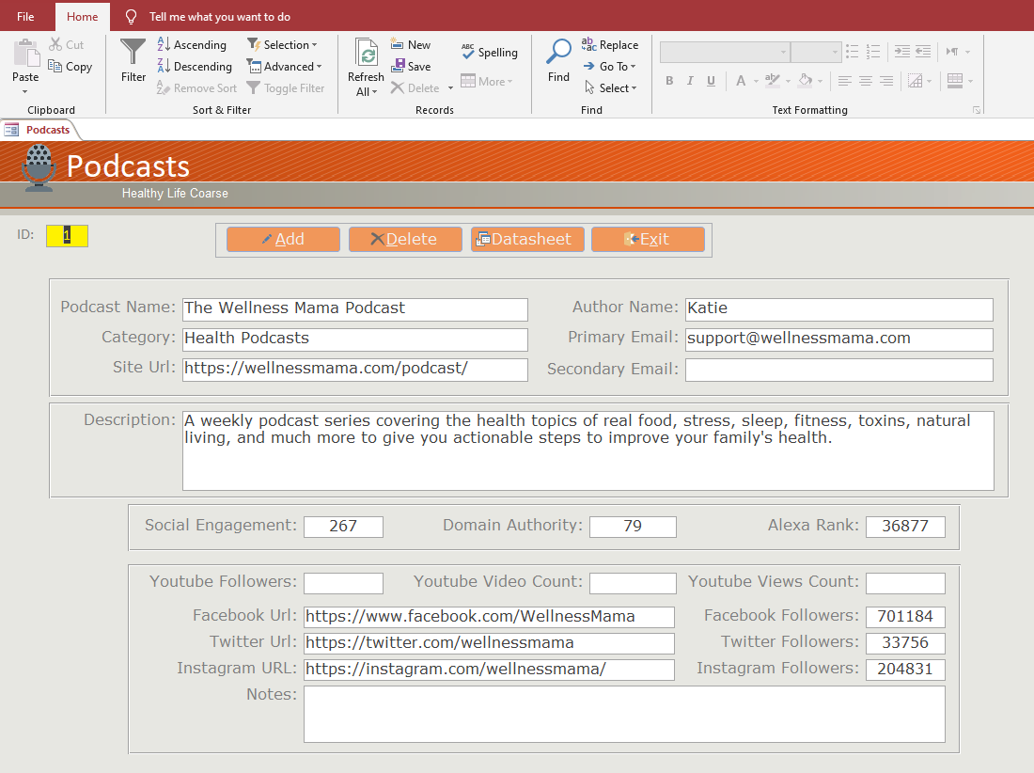

The second is a Datasheet view that looks like an Excel spreadsheet.

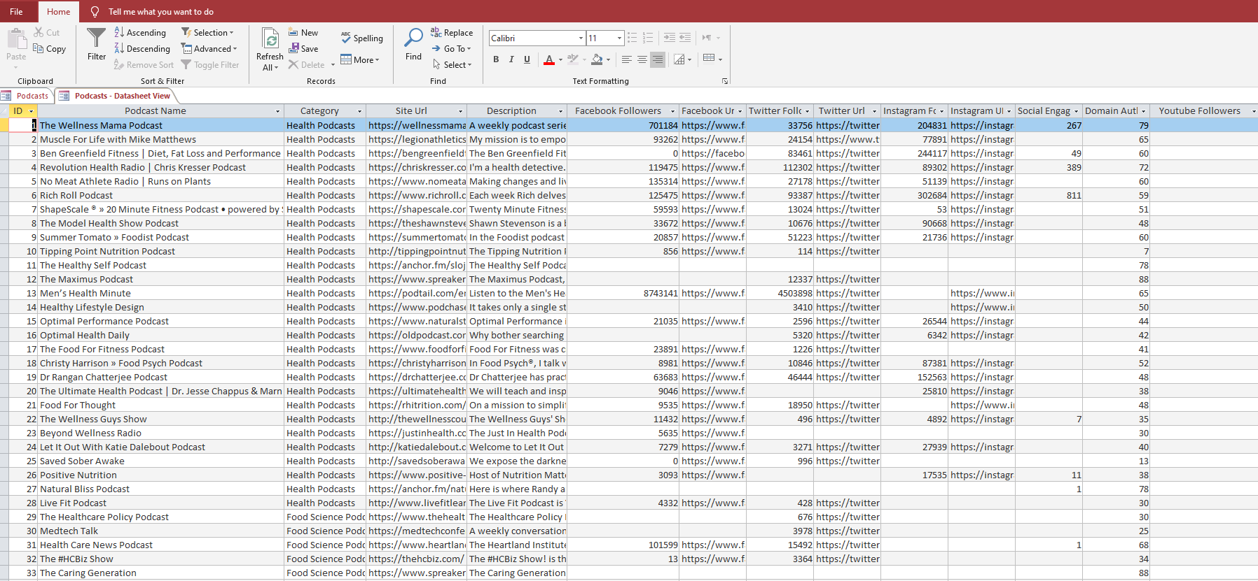

The Add and Delete records function is self-explanatory. In order to search records, you use the Find tool on the Toolbar.

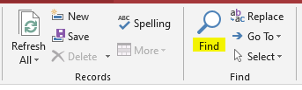

To search by a field, first place the cursor in the textbox you wish to search and then select the Find tool. For instance, if I want to find records that have the word “nutrition” in the description, I place the cursor the Description textbox, select the Find tool, type in the word “nutrition”. If I want to find an exact word match in the current textbox, it woul look like this:

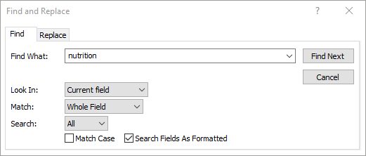

Under the Match dropdown box, you can select to search “Any Part of Field” which means it’s a wildcard search similar to doing this: “\*nutrition\*”, You can also select “Start of Field, which means it will find all records where the description begins with the word “nutrition\*”. You can also make it case sensitive and search fields as formatted. If you want to search ALL fields, use the “Look In” dropdown box and select Current Document to search the entire recordset.

You can also Sort and Filter by using the tools on the toolbar.

